**Effect of Three-Class Strategy vs Two-Class Strategy on the Hazard of Aids**

3/17/2024, Kath Fillman

**Introduction.**  This analysis used data from a study on the efficacy of antiviral medication with a three-class strategy of PI, NNRTI, and NRTI compared to a two-class strategy of PI and NRTI or NNRTI and NRTI; researchers also examined which was a better initial therapy. This analysis aimed to find how the three-class strategy affects the hazard of AIDS relative to the two-class strategy while adjusting for both the clinical unit and rather or not the patent’s baseline CD4 count was above 200.

**Dataset.** The dataset first6.csv was provided by the instructor. It contained 1397 observations of 33 variables; these included the participant’s age, gender, race, and viral load and CD4 at various times. Variables of interest include whether or not the participant had an AIDS event (excluding death), the time to AIDS event or censoring, which treatment strategy they were assigned to, rather or not their baseline CD4 was above 200, and the clinical unit conducting the study.

**Exploratory Data Analysis.** 933 participants were assigned the two-class treatment and 464 participants received the three-class treatment. The average number of AIDS events (excluding death) was 13.40% for those in the two-class treatment group and 12.93% for those in the tree-class treatment group (table 1). This means that those in the two-class treatment group had a slightly higher number of AIDS events relative to those in the three-class group. The average amount of time to an AIDS event (excluding death and censoring) in months was about even between the groups with the two-class group having a mean of 49.9520 and the three-class group with a mean of 49.0464. The same is seen for the CD4 being above 200 with the two-class group having a mean of 0.4491 and the three-class group having a mean of 0.4440 (table 1). The Kaplan-Meier plot seen in figure 1 shows an unadjusted model. The curves in this plot are relatively similar, although the % without an AIDS event in the two-class treatment group is often below that of the three-class group, especially toward the edges of the plot (figure 1).

**Methods.** The exploration of how the three-class strategy affects the hazard of AIDS relative to the two-class strategy while adjusting for both the clinical unit and rather or not the patent’s baseline CD4 count was above 200 was investigated using Cox regression. P-values less than 0.05 were significant. All analyses were performed in R-studio version 2023.12.1, build 402.

**Results.** The hazard ratio of a three-class strategy compared to a two-class strategy is 0.9524 (table 2). The outcomes of the model are shown in table 2; the only significant factor was if the patient had a baseline CD4 of over 200. The model fulfills the proportional hazard assumption as there is no correlation between time and any of the factors as seen in the Schoenfeld individual test (figure 2).

**Conclusions.** Using the three-class strategy decreases the hazard of an AIDS event by a factor of 0.9524 or 9.524%. In this study, while adjusting for both the clinical unit and rather or not the patient's baseline CD4 count was above 200, it was found that the three-class strategy decreased the hazard of an AIDS event.

**Appendix.**

**Table 1.**

|  | Two-Class vs Three-Class | |
| --- | --- | --- |
|  | Two-Class | Three-Class |
| Number of Patients | 933 | 464 |
| Mean AIDS Event Excluding Death | 0.1340 | 0.1293 |
| Mean Time to AIDS Event not Including Death or Censoring (Months) | 49.9520 | 49.0464 |
| Mean CD4 Above 200 at Baseline | 0.4491 | 0.4440 |

**Table 2.**

|  | Hazard Ratio | 95% Confidence Interval | P-value |
| --- | --- | --- | --- |
| Three-Class Strategy | 0.9524 | 0.6995, 1.2967 | 0.7568 |
| Baseline CD4 Count Above 200 | 0.1957 | 0.1305, 0.2933 | 2.82e-15 |
| Unit 5 | 1.5136 | 0.7398, 3.0969 | 0.2565 |
| Unit 7 | 1.2410 | 0.5356, 2.8752 | 0.6146 |
| Unit 8 | 0.9338 | 0.4194, 2.0790 | 0.8667 |
| Unit 9 | 1.4653 | 0.6464, 3.3217 | 0.3602 |
| Unit 10 | 0.5959 | 0.1922, 1.8481 | 0.3700 |
| Unit 12 | 0.6953 | 0.2608, 1.8540 | 0.4677 |
| Unit 14 | 0.3380 | 0.1090, 1.0483 | 0.0603 |
| Unit 15 | 1.1948 | 0.3364, 4.2438 | 0.7831 |
| Unit 16 | 1.2399 | 0.6093, 2.5232 | 0.5530 |
| Unit 17 | 1.0982 | 0.4844, 2.4894 | 0.8226 |
| Unit 18 | 1.3442 | 0.6286, 2.8742 | 0.4456 |
| Unit 19 | 0.7686 | 0.3553, 1.6624 | 0.5037 |
| Unit 20 | 1.1844 | 0.5478, 2.5609 | 0.6671 |
| Unit 22 | 1.1354 | 0.3661, 3.5217 | 0.8259 |
| Unit 23 | 1.4106 | 0.5550, 3.5853 | 0.4698 |
| Unit 24 | 0.8458 | 0.3731, 1.9174 | 0.6885 |
| Unit 25 | 1.1268 | 0.4228, 3.0031 | 0.8113 |

**Figure 1.**

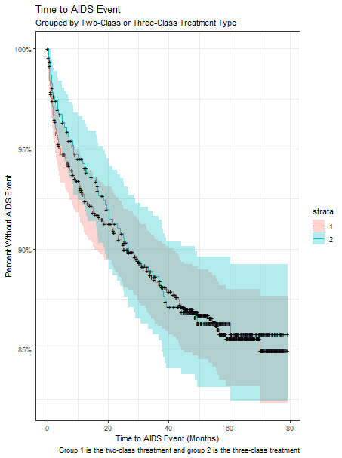

**Figure 2.**

